

OPERATION ACTIVE RESOLVE INTELLIGENCE REPORT

**RUSSIAN S-300 VARIANTS**

# General Information

This intelligence report contains information about the Russian S-300 variants.

# Intelligence

## Russian S-300 system

Russian have developed advanced SAM systems the recent years. The capability of these systems has not been know. VID have received a Russian internal document about the S-300 system from trusted sources.

The following pictures are extracted from the Russian document:

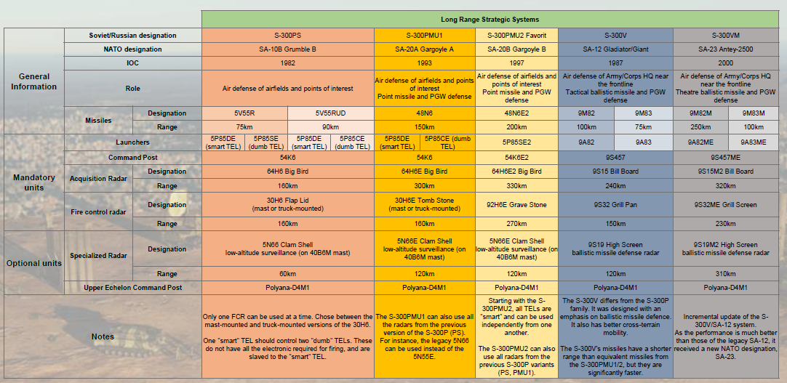

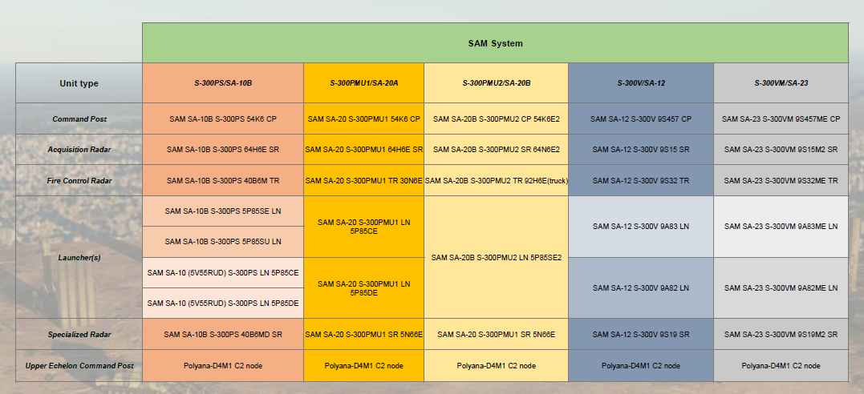

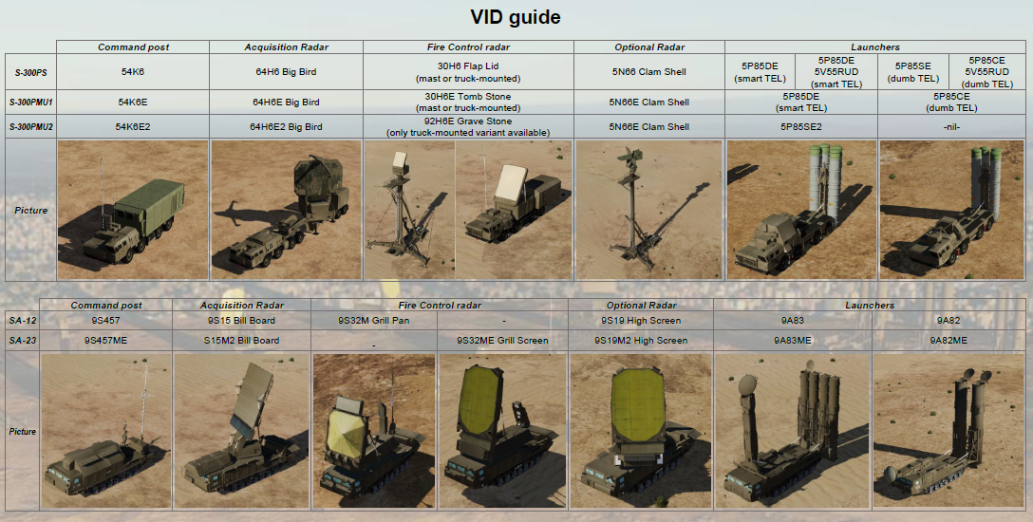

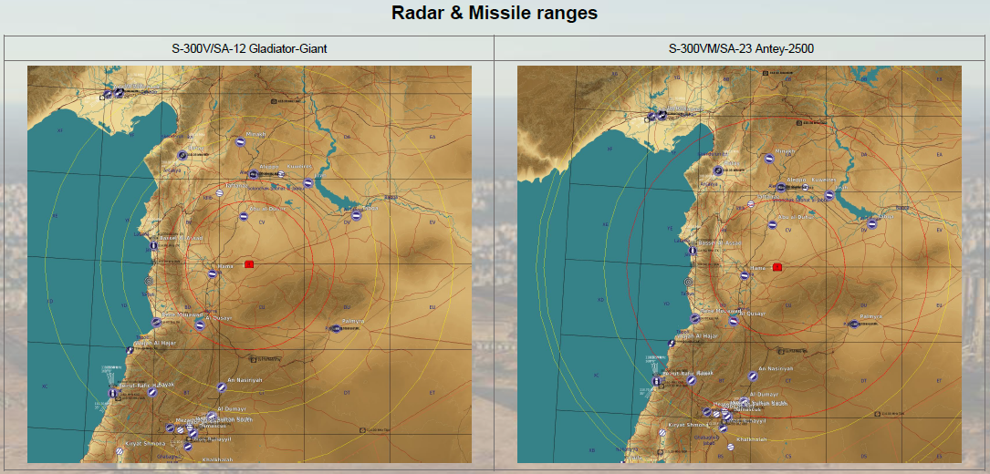

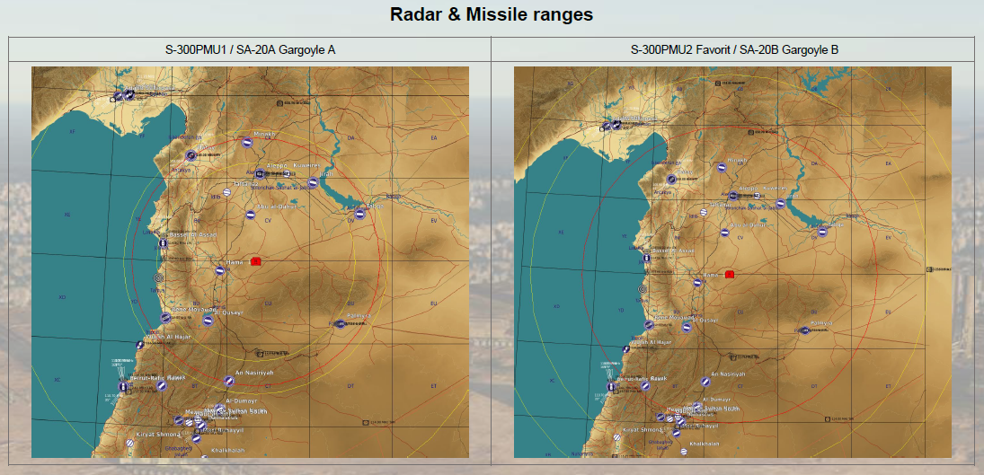

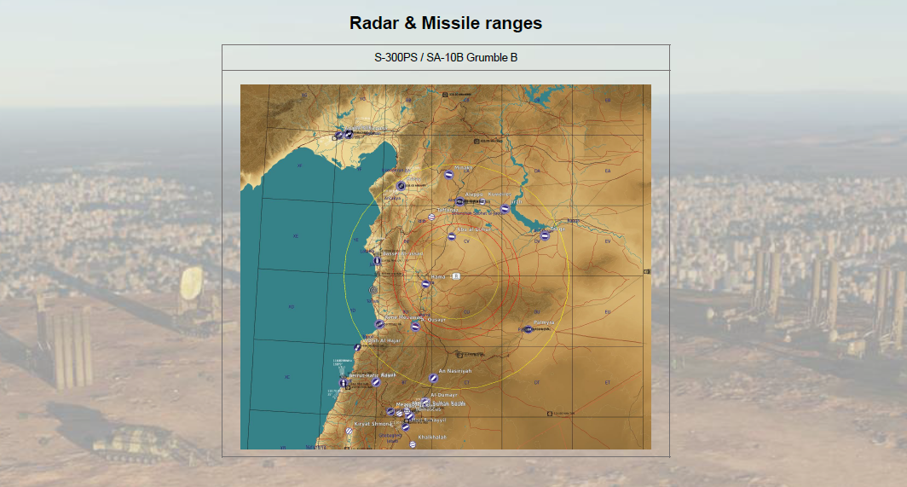

**ASSESSMENT:**

It is HIGHLY LIKELY that the information is correct and that the capabilities of the systems are as shown on the pictures

# VID Information gaps

## Intelligence Requirements

The following are intelligence requirements VID request support from VIS to answer.

### Intelligence Requirement X (IR X): What is the status of Russian SAM’s in the area of operation?

* + Are Russian S-300 systems in the area of operation?
  + Are Russian S-300 capabilities as described in this report?